Week 5:
In week 5, I created a topology that has four hosts (Host1 to Host4) that is linked to a switch. I also assigned each host with static IP address and netmask and a gateway.

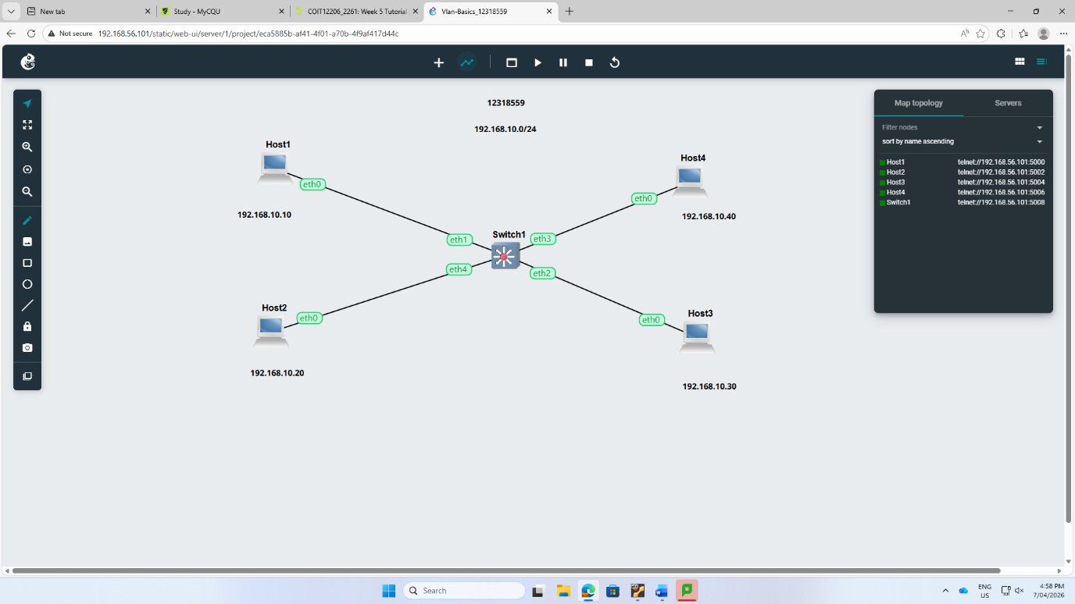
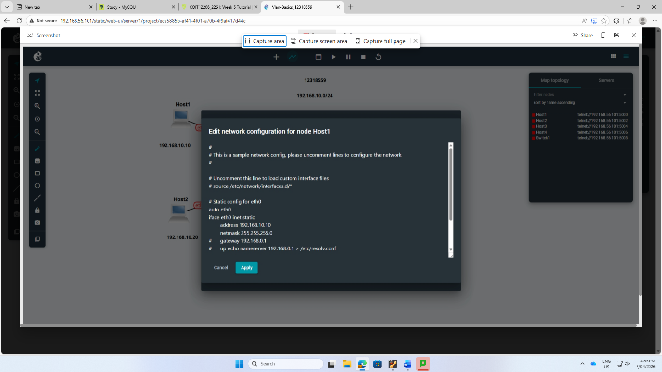

Step 2: I also used the ping command to examine the connectivity between hosts. Somehow, if the devices are not configured well, then the output will be”Destination Host Unreachable.”
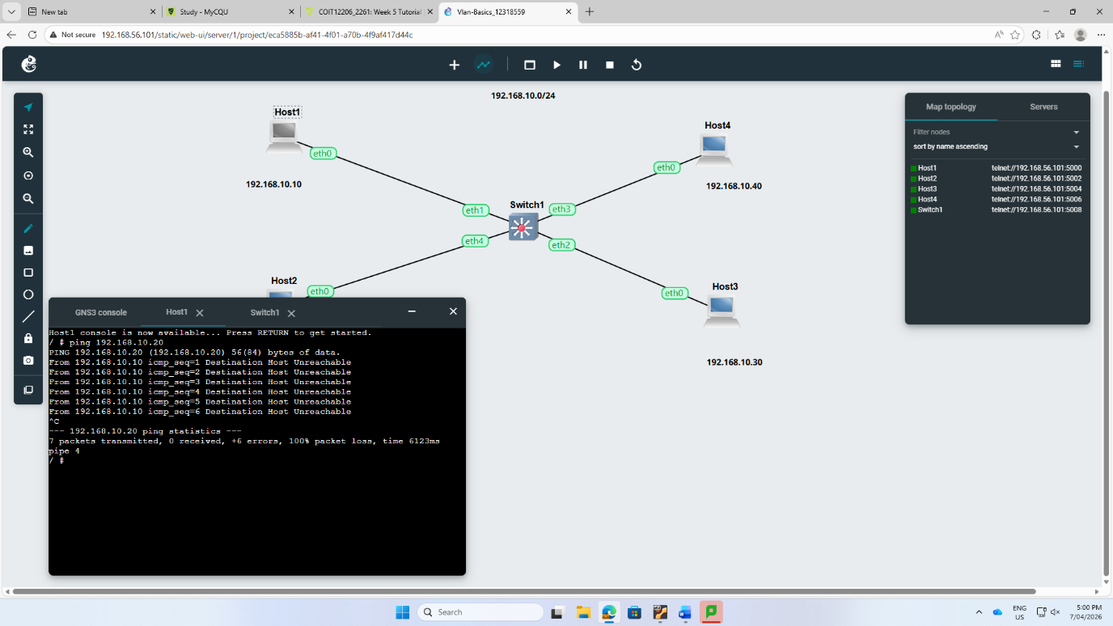

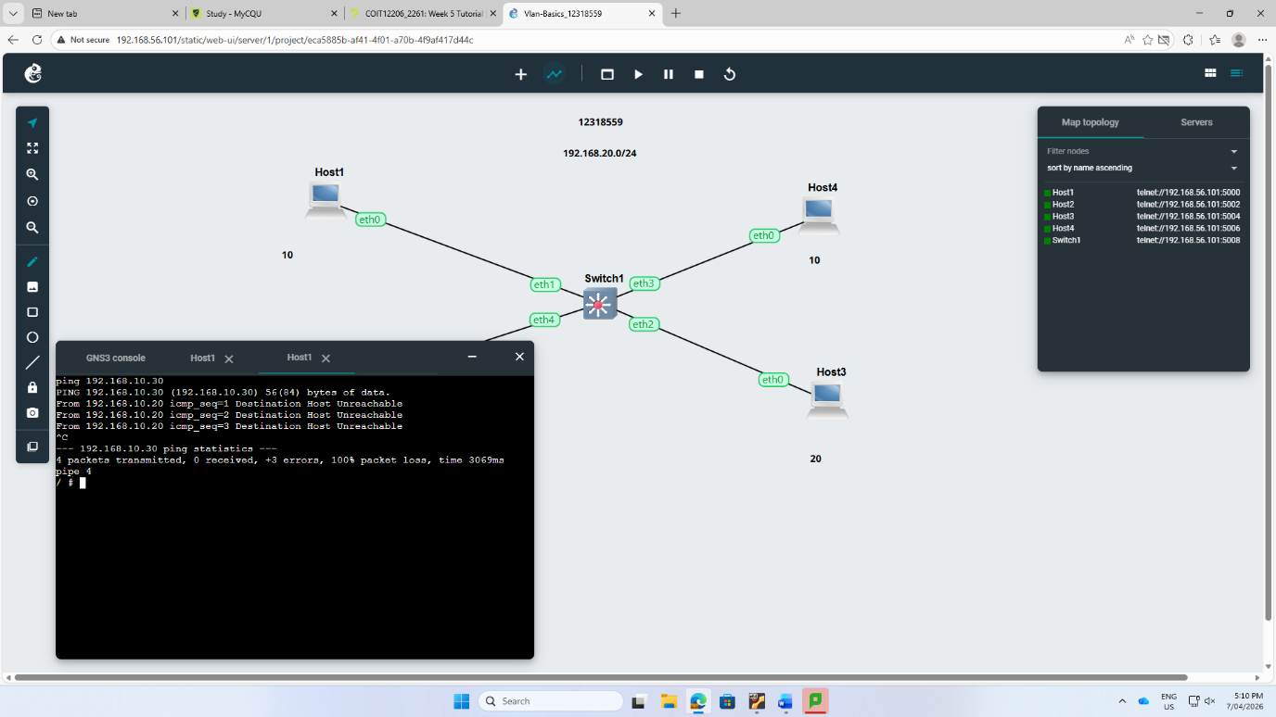

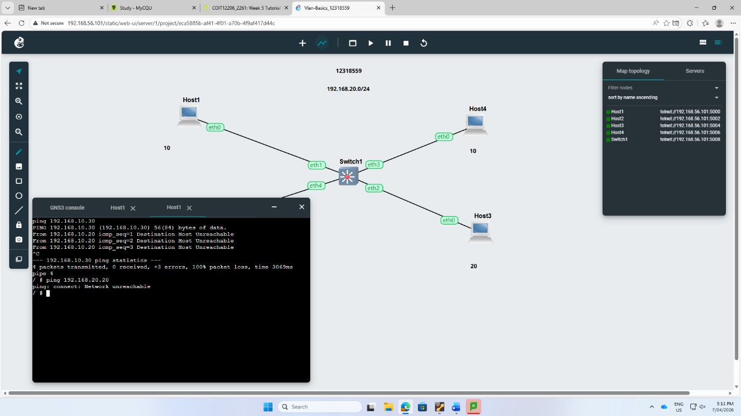
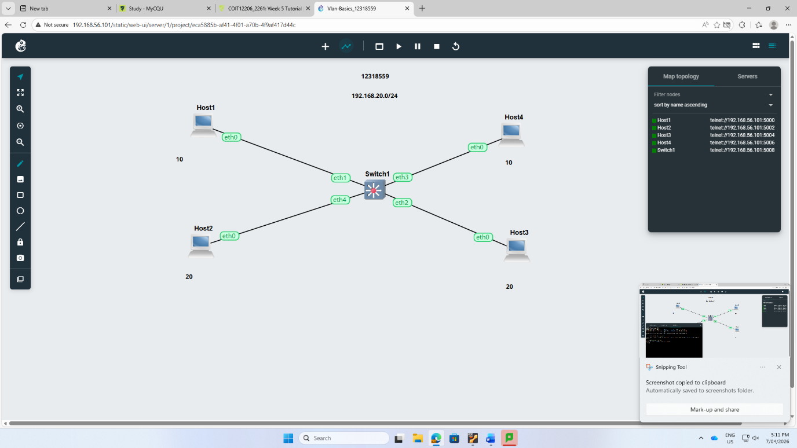

Step 3: I allowed the switch1 web console and make sure the open vSwitch service is working with the command “sh /etc/openvswitch/init.sh.”
Step 4: Assign the each ports to VLANs using ovs-vsctl show command.

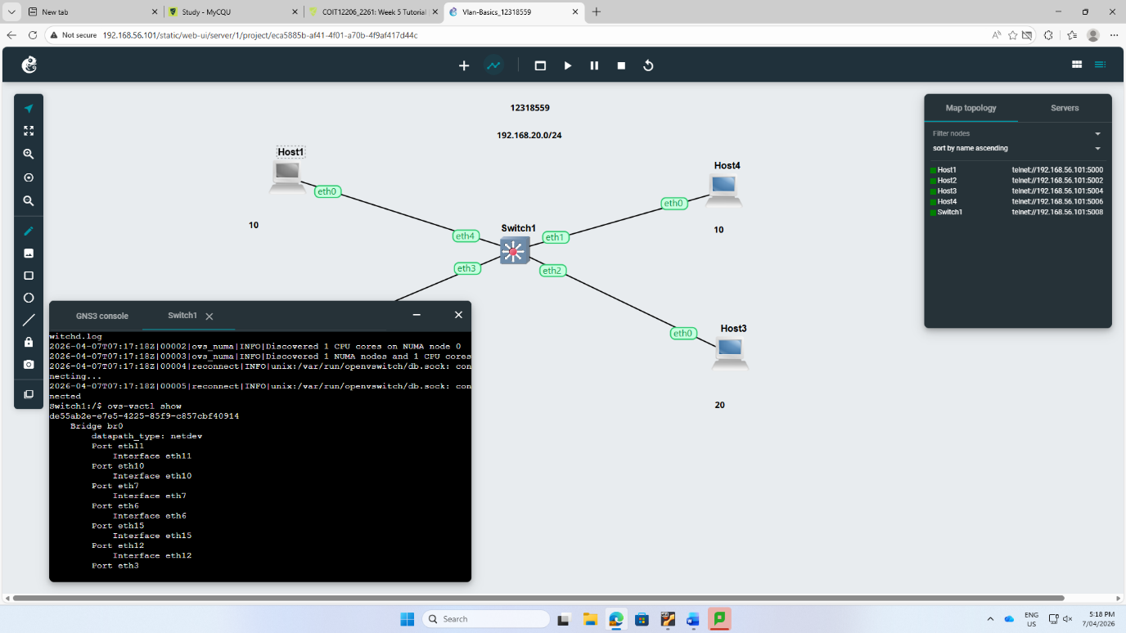
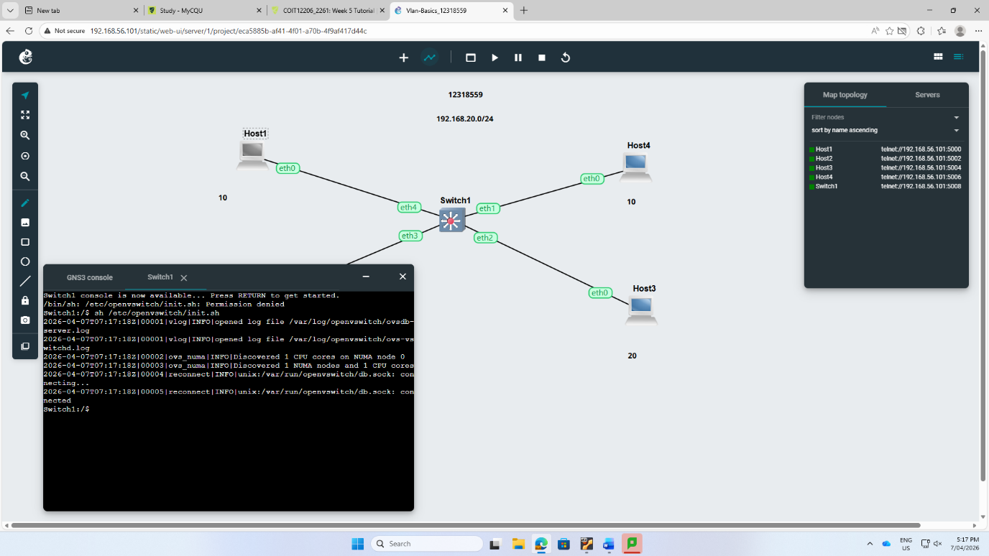

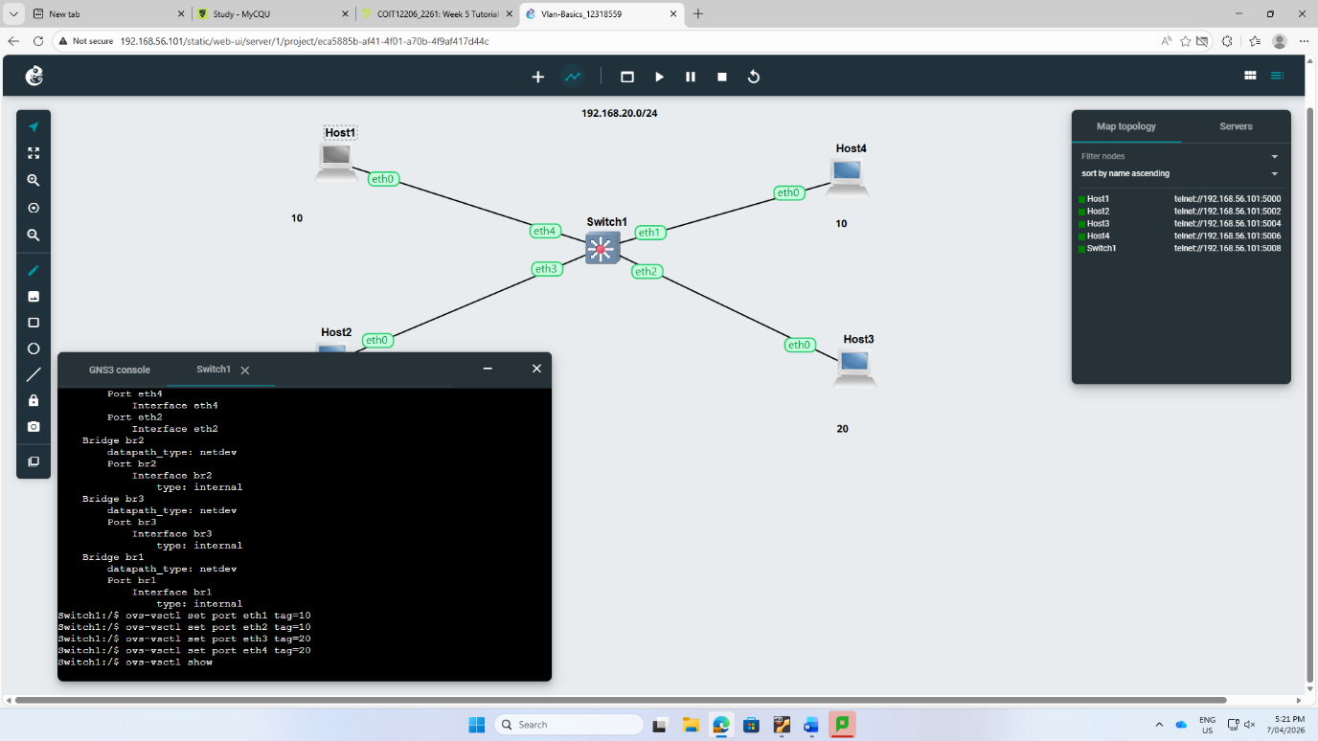
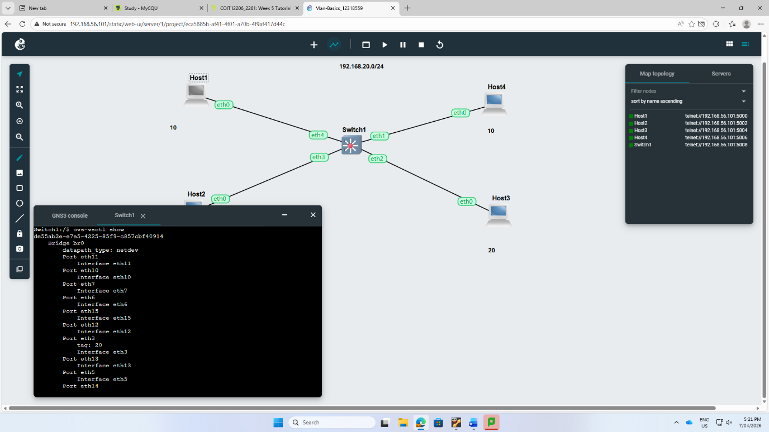

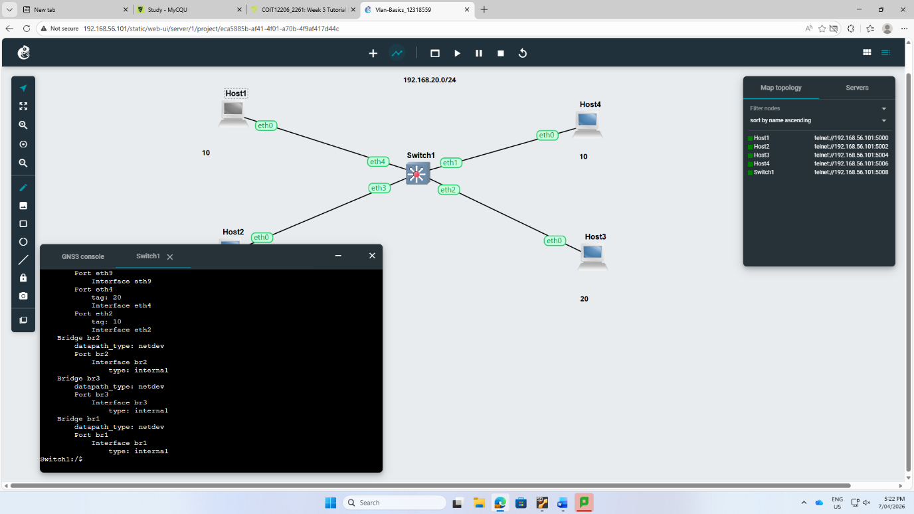
Step 5: I tried to ping the hosts but unfortunately it didn’t work.
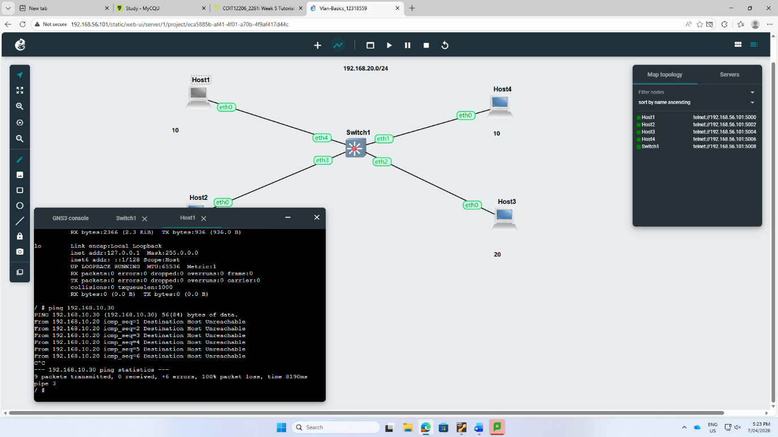

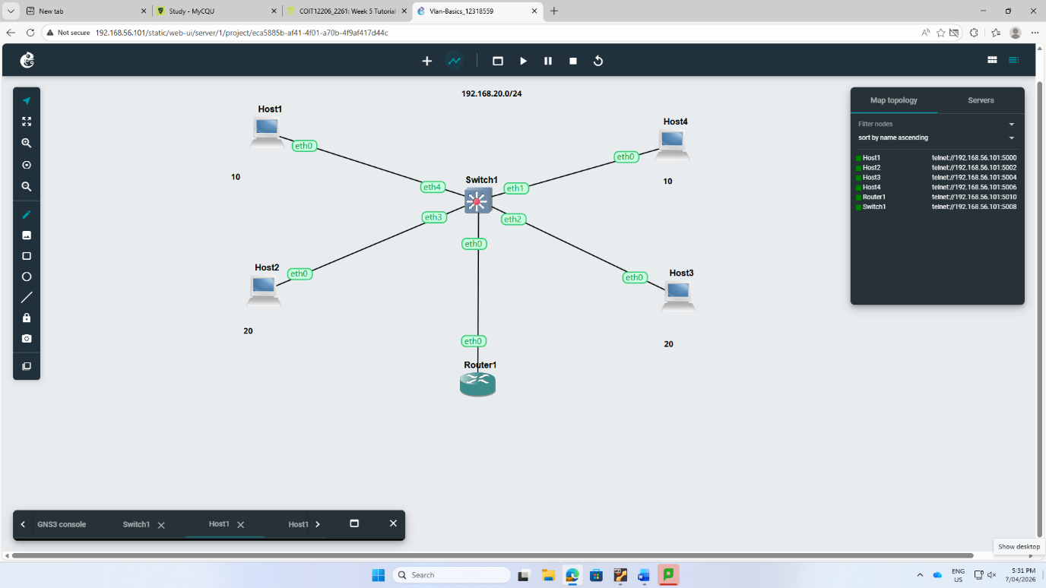
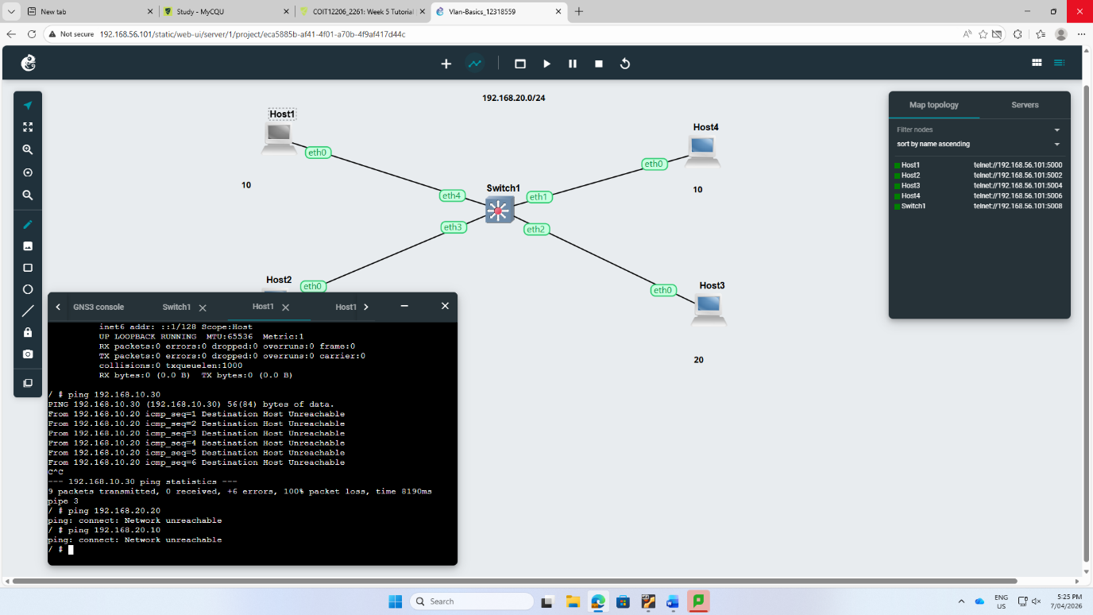

Step 6: The clear screenshot of topology is given below.

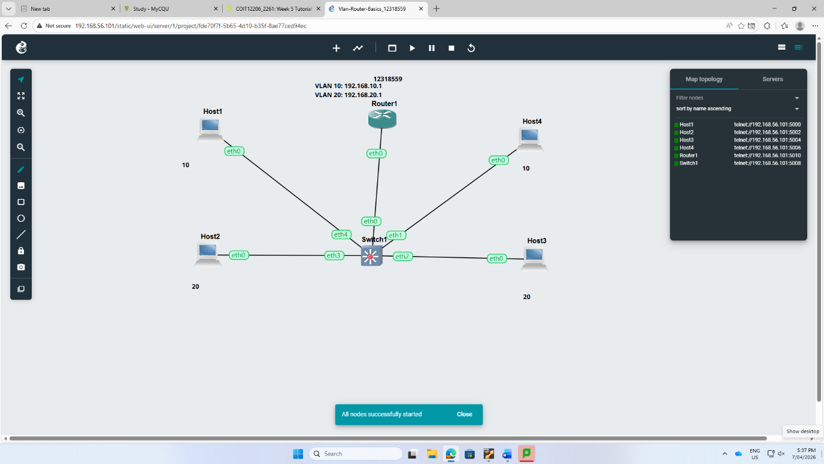
Step 7: I used the command ip link add link eth0 name eth0.10 type vlan id 10 and developed eth0.10 and eth0.20.

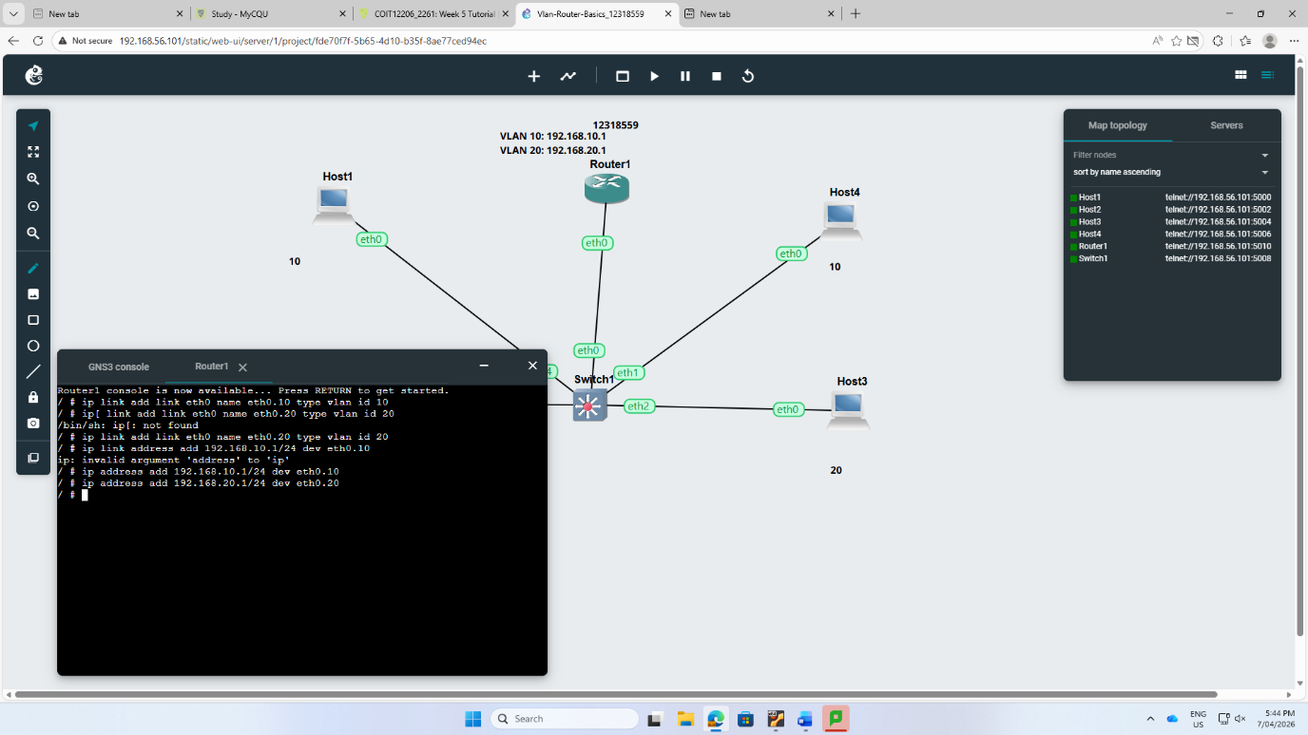

Step 8: I tried to ping but couldn’t success.
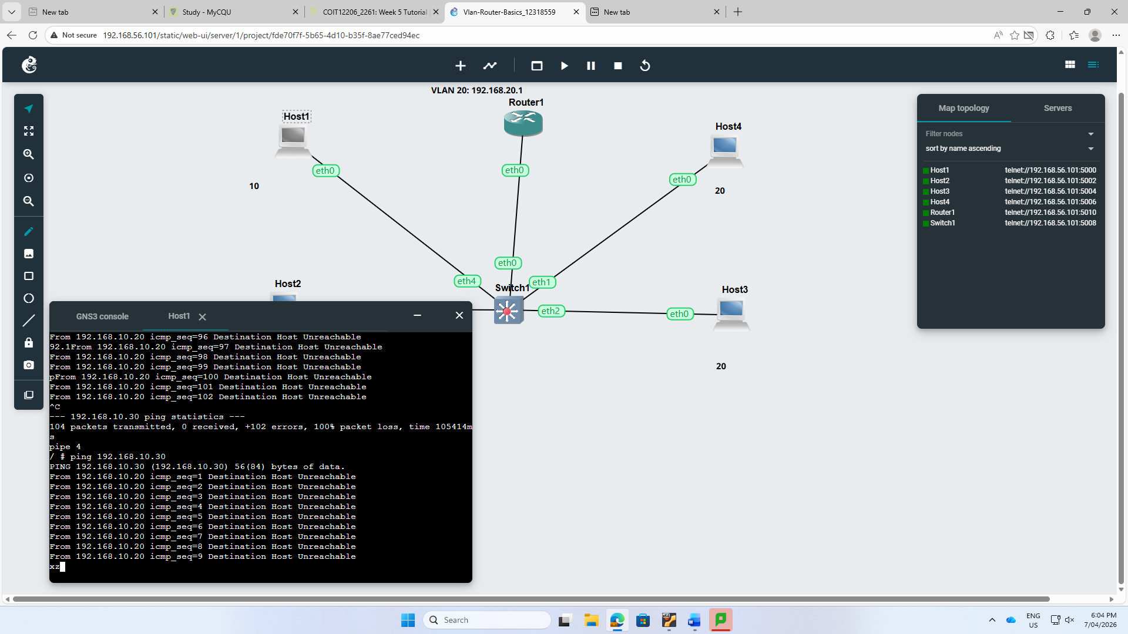

Reflection:
In week 5, I learnt about the process of switches and routers work together. Talking more, I built up the confidence in using virtualized network environments and errors about connectivity connected to IP addressing and VLAN tagging.

